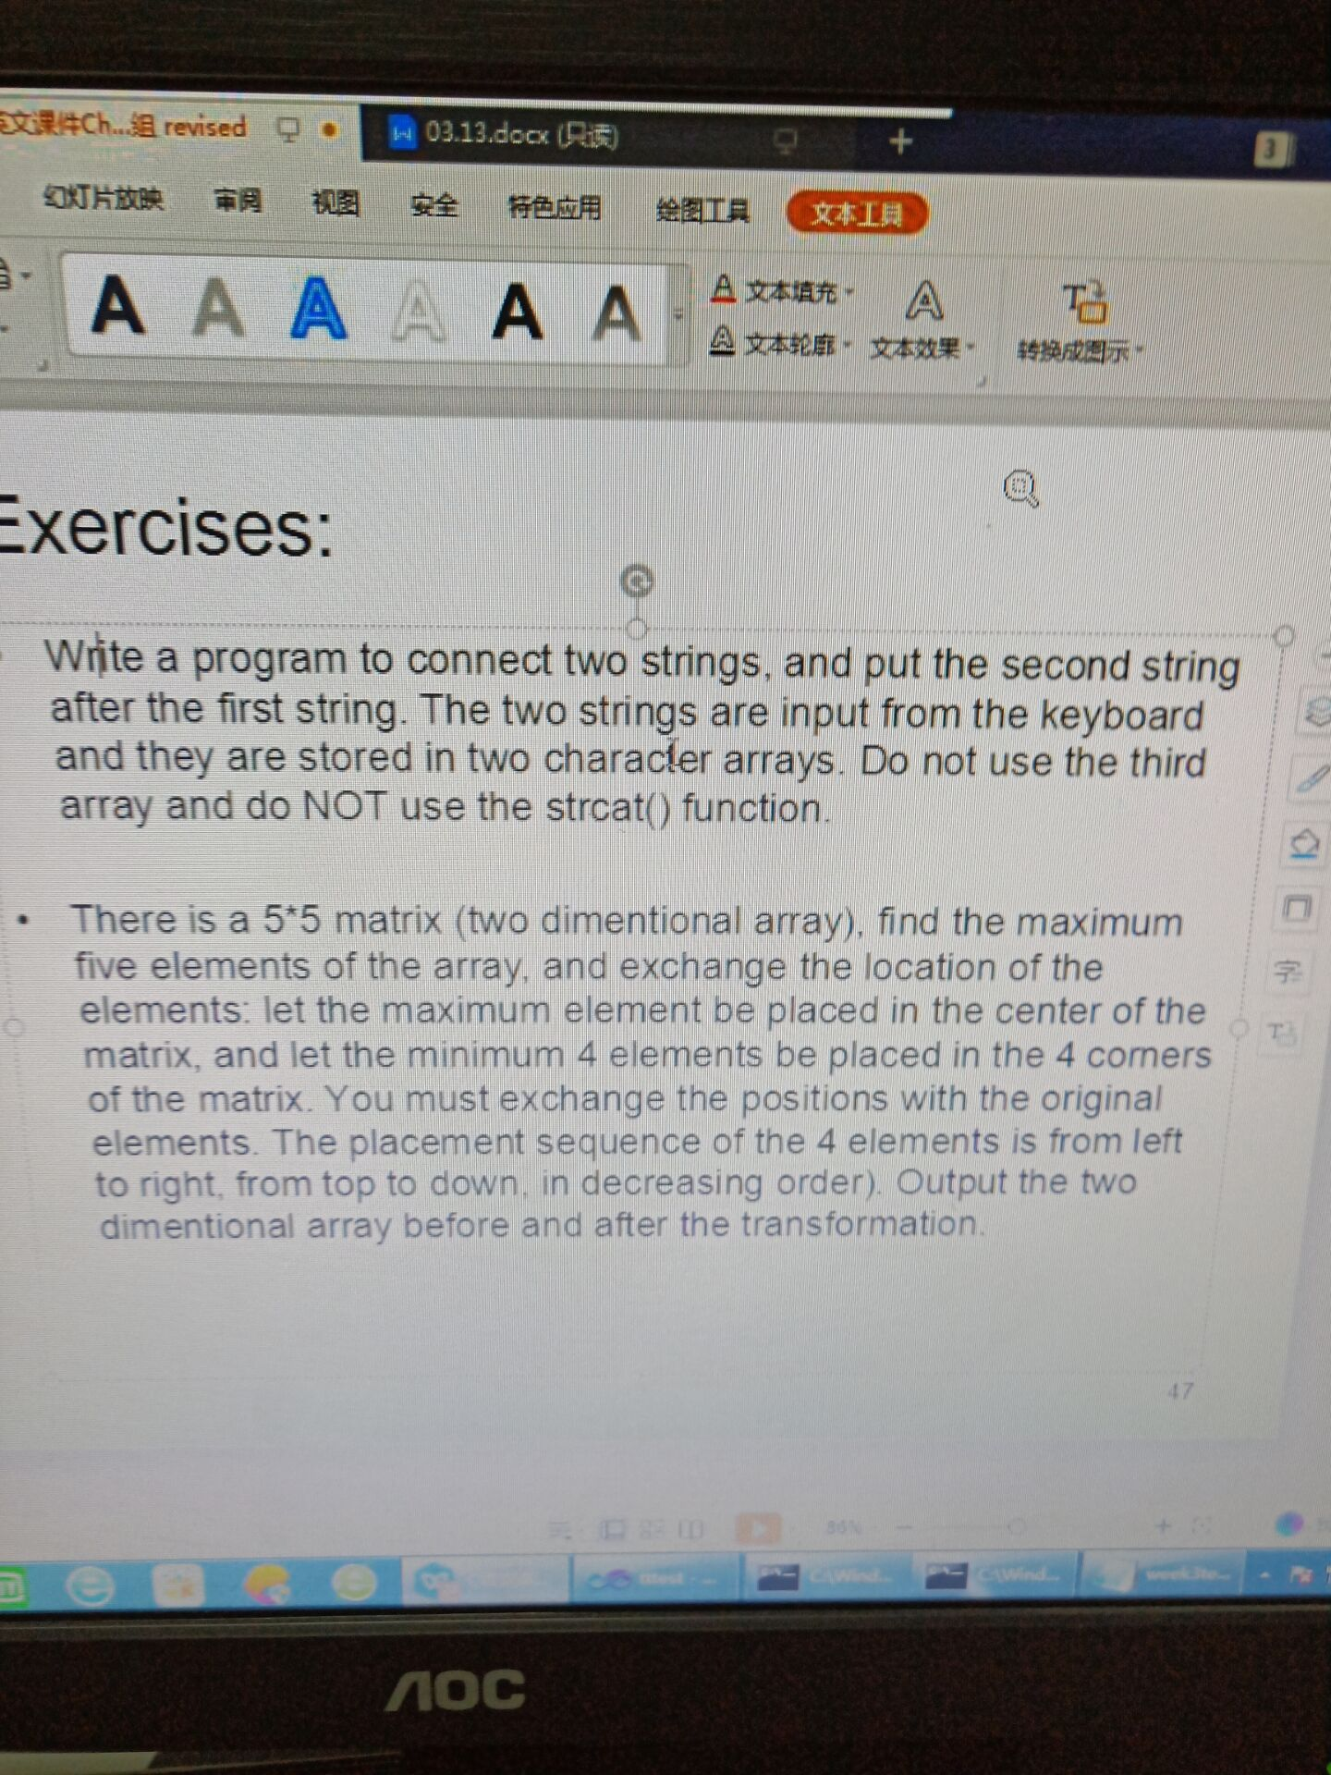

## 源代码：

#include <stdio.h>

#define number 25

int main()

{

int a[5][5], rank[25],x,y,process,time, i = 0;

//输入数组

printf("请输入一个5*5的数组：\n");

for (x = 0; x < 5; x++)

{

for (y = 0; y < 5; y++)

{

scanf("%d", &a[x][y]);

}

}

//展示数组

printf("\n\n交换前的数组为：\n");

for (x = 0; x < 5; x++)

{

for (y = 0; y < 5; y++)

{

printf("%-5d", a[x][y]);

}

printf("\n");

}

//将二维数组输入到一维排序数组里：

for (x = 0; x < 5; x++)

{

for (y = 0; y < 5; y++)

{

rank[i]=a[x][y];

i++;

}

}

//冒泡排序：

for (time = 1; time < 5; time++)

{

for (i = 0; i < number - time; i++)

{

if (rank[i] > rank[i + 1])

{

process = rank[i];

rank[i] = rank[i + 1];

rank[i + 1] = process;

}

}

}

printf("\n最大的五个数为：");

for (i = 24; i >= 20; i--)

{

printf("%4d", rank[i]);

}

//交换位置

for (x = 0; x < 5; x++)

{

for (y = 0; y < 5; y++)

{

if (rank[24] == a[x][y])

{

a[x][y] = a[2][2];

a[2][2] = rank[24];

break;

}

}

}

for (x = 0; x < 5; x++)

{

for (y = 0; y < 5; y++)

{

if (rank[23] == a[x][y])

{

a[x][y] = a[0][0];

a[0][0] = rank[23];

break;

}

}

}

for (x = 0; x < 5; x++)

{

for (y = 0; y < 5; y++)

{

if (rank[22] == a[x][y])

{

a[x][y] = a[0][4];

a[0][4] = rank[22];

break;

}

}

}

for (x = 0; x < 5; x++)

{

for (y = 0; y < 5; y++)

{

if (rank[21] == a[x][y])

{

a[x][y] = a[4][0];

a[4][0] = rank[21];

break;

}

}

}

for (x = 0; x < 5; x++)

{

for (y = 0; y < 5; y++)

{

if (rank[20] == a[x][y])

{

a[x][y] = a[4][4];

a[4][4] = rank[20];

break;

}

}

}

//输出新数组

printf("\n\n交换后的新数组为：\n");

for (x = 0; x < 5; x++)

{

for (y = 0; y < 5; y++)

{

printf("%-5d", a[x][y]);

}

printf("\n");

}

return 0;

}

## 输出结果



## 源代码：

#include <stdio.h>

#include <string.h>

int main()

{

char c;

char str_1[100], str_2[100];

int length_1, length_2, i;

printf("请输入第1个字符串：");

c = getchar();

str_1[0] = c;

i = 0;

while (c != 10)

{

i++;

c = getchar();

str_1[i] = c;

}

length_1 = strlen(str_1);

printf("请输入第2个字符串：");

c = getchar();

str_2[0] = c;

i = 0;

while (c != 10)

{

i++;

c = getchar();

str_2[i] = c;

}

length_2 = strlen(str_2);

for (i = 0; i < length_2; i++)

{

str_1[length_1 - 1 + i] = str_2[i];

}

printf("\n\n把第2个字符串放在第1个字符串后面得：");

for (i = 0; i < (length_1 + length_2); i++)

{

printf("%c", str_1[i]);

}

return 0;

}

## 输出结果：

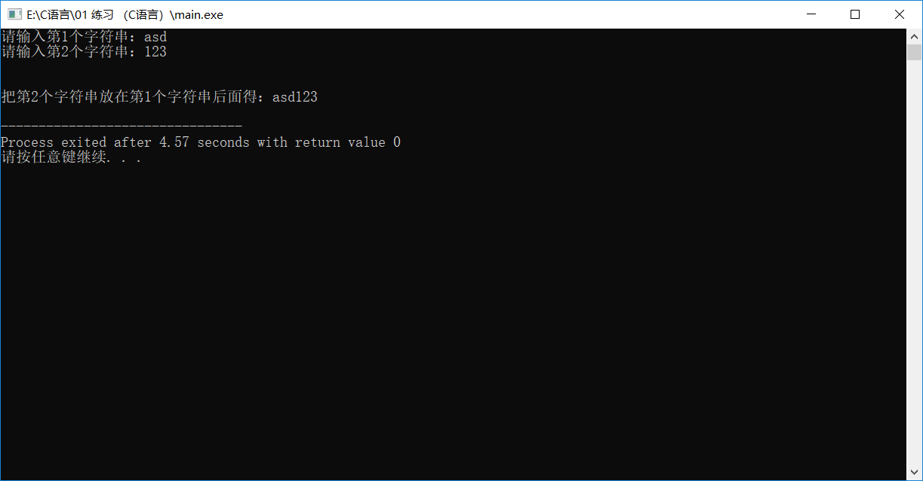

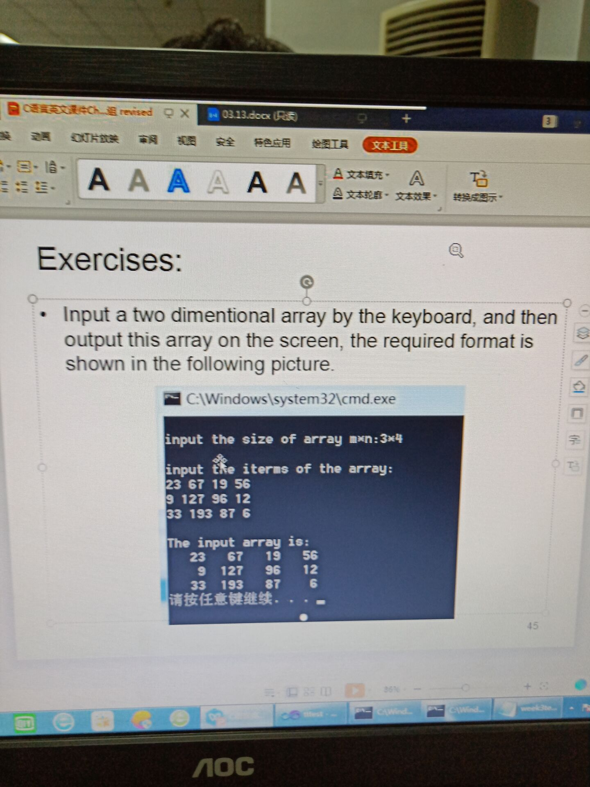

## 源代码：

#include <stdio.h>

int main()

{

int a[10][10] = { 0 }, x,y,i,j;

printf("Input the size of array:");

scanf("%d*%d", &x, &y);

printf("\nInput the items of the array:\n");

for (i = 0; i < x; i++)

{

for (j = 0; j < y; j++)

scanf("%d", &a[i][j]);

}

printf("\nThe input array is：\n");

for (i = 0; i < x; i++)

{

for (j = 0; j < y; j++)

printf("%5d ", a[i][j]);

printf("\n");

}

return 0;

}

## 输出结果：

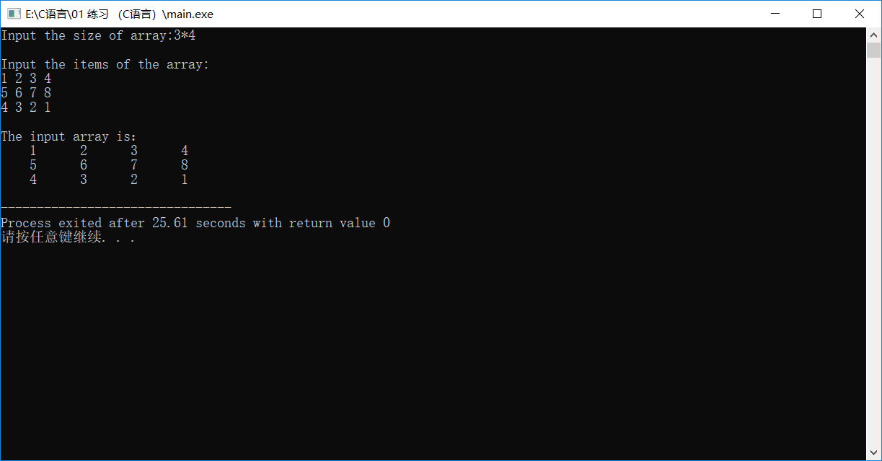

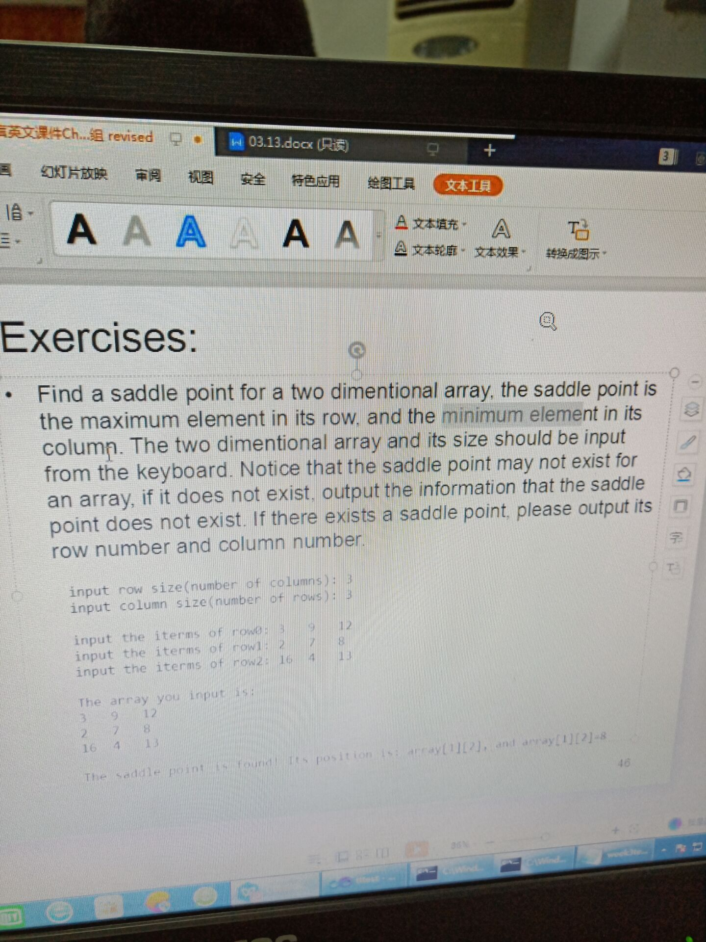

## 源代码：

#include<stdio.h>

int main()

{

int a[30][30] = { 0 }, min, max, i, j, x, y, n,judge=1;

printf("Input row size(number of columns): ");

scanf("%d", &x);

printf("Input column size(number of rows): ");

scanf("%d", &y);

//输入矩阵

printf("\n");

for (i = 0; i < x; i++)

{

printf("Input the iterms of row%d: ",i);

for (j = 0; j < y; j++)

scanf("%d", &a[i][j]);

}

//输出矩阵

printf("\nThe array you input is:\n");

for (i = 0; i < x; i++)

{

for (j = 0; j < y; j++)

printf("%-5d", a[i][j]);

printf("\n");

}

//找鞍点

for (i = 0; i < x; i++)

{

max = a[i][0];

n = 0;

for (j = 1; j < y; j++)

{

if (max < a[i][j])

{

max = a[i][j];

n = j;

}

}

min = a[0][n];

for (j = 1; j < x; j++)

{

if (min > a[j][n])

min = a[j][n];

}

if (min == max)

{

printf("\nThe saddle point is found! It's position is: array[%d][%d], and array[%d][%d]=%d", i, n, i, n, min);

judge = 0;

break;

}

}

if (judge == 1)

printf("\nThis array hasn't the saddle point!");

return 0;

}

## 输出结果：

